Junit Testing

EXERCISE 1: SETTING UP

TEST CLASS:

import org.junit.Test;

import static org.junit.Assert.\*;

public class CalculatorTest {

*@Test*

public void testAdd() {

Calculator calc = new Calculator();

int result = calc.add(10, 5);

*assertEquals*(15, result);

}

}

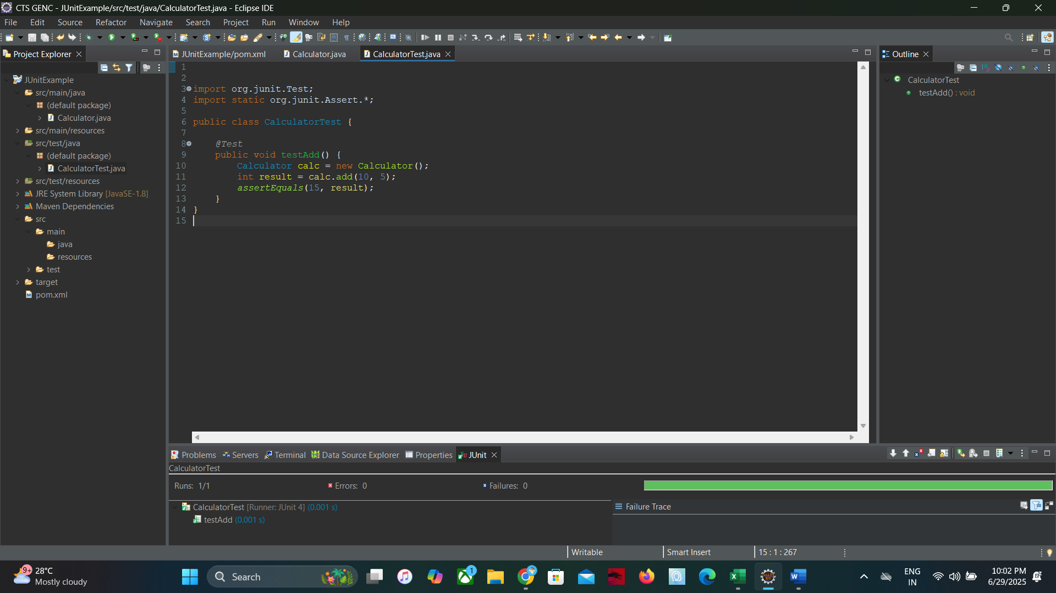

Exercise 3: Assertions in Junit

AssertionTest Class:

package com.example;

import org.junit.Test;

import static org.junit.Assert.\*;

public class AssertionsTest {

@Test

public void testAssertions() {

// Assert equals

assertEquals(5, 2 + 3);

// Assert true

assertTrue(5 > 3);

// Assert false

assertFalse(5 < 3);

// Assert null

assertNull(null);

// Assert not null

assertNotNull(new Object());

}

}

EXERCISE 4:

CREATE A SAMPLE CLASS CALCULATOR

package com.example;

public class Calculator {

public int add(int a, int b) {

return a + b;

}

public int divide(int a, int b) {

return a / b; // Will throw ArithmeticException if b == 0

}

}

CREATE A TEST CLASS CALCULATORTEST

package com.example;

import org.junit.After;

import org.junit.Before;

import org.junit.Test;

import static org.junit.Assert.\*;

public class CalculatorTest {

private Calculator calculator;

// Setup method (runs before each test)

@Before

public void setUp() {

calculator = new Calculator();

System.out.println("Setup - Calculator instance created");

}

// Teardown method (runs after each test)

@After

public void tearDown() {

System.out.println("Teardown - Cleaning up");

}

// Test using AAA pattern

@Test

public void testAddition() {

// Arrange

int a = 5;

int b = 3;

// Act

int result = calculator.add(a, b);

// Assert

assertEquals(8, result);

}

@Test

public void testDivision() {

// Arrange

int a = 10;

int b = 2;

// Act

int result = calculator.divide(a, b);

// Assert

assertEquals(5, result);

}

@Test(expected = ArithmeticException.class)

public void testDivideByZero() {

// Arrange

int a = 10;

int b = 0;

// Act (should throw exception)

calculator.divide(a, b);

// Assert - handled by expected exception

}

}

